9.Implement the image scaling techniques to resize the images to both bigger and small sizes.

**AIM:**

To implement image scaling techniques in Python using OpenCV to resize an image to both **bigger** and **smaller** sizes.

**PROCEDURE:**

1. Install OpenCV (if not already installed):

* pip install opencv-python

1. Import required libraries:

* Use cv2 for image processing.

1. Read the input image using cv2.imread().
2. Resize the image to a bigger size using cv2.resize() with a scaling factor greater than 1.
3. Resize the image to a smaller size using cv2.resize() with a scaling factor less than 1.
4. Use different interpolation methods:
   1. cv2.INTER_LINEAR (default, for enlargement).
   2. cv2.INTER_AREA (for shrinking).
5. Display the original, enlarged, and reduced images using cv2.imshow().
6. Wait for a key press & close windows using cv2.waitKey(0) and cv2.destroyAllWindows().

**PROGRAM:**

import cv2

# Read the image

image = cv2.imread("sample.jpg") # Replace with your image file

# Resize to a bigger size (2x scaling)

bigger_image = cv2.resize(image, None, fx=2, fy=2, interpolation=cv2.INTER_LINEAR)

# Resize to a smaller size (0.5x scaling)

smaller_image = cv2.resize(image, None, fx=0.5, fy=0.5, interpolation=cv2.INTER_AREA)

# Display images

cv2.imshow("Original Image", image)

cv2.imshow("Bigger Image", bigger_image)

cv2.imshow("Smaller Image", smaller_image)

# Wait for a key press and close the windows

cv2.waitKey(0)

cv2.destroyAllWindows()

**INPUT:**

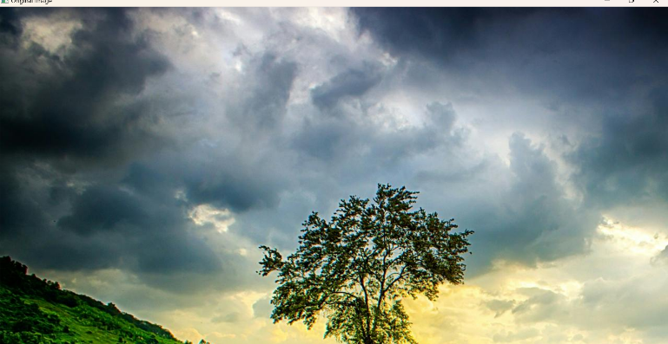

**OUTPUT:**

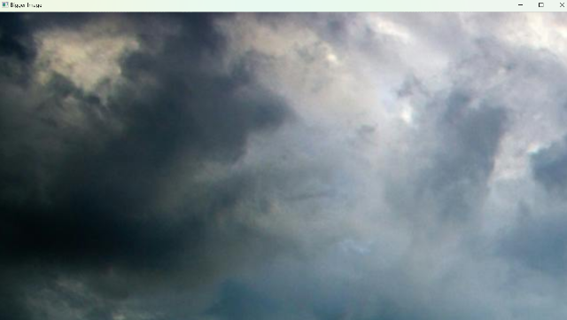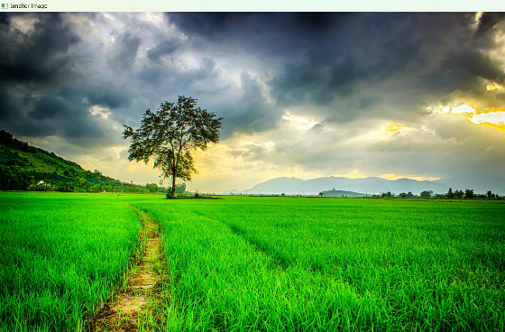

**RESULT :**

Successfully resized an image to **both bigger and smaller sizes** using OpenCV.